VK registration

Added 26 april 2018.

1. To register your application follow next steps.  
   Use the link: https://vk.com/dev.  
   Click the “My apps” button.

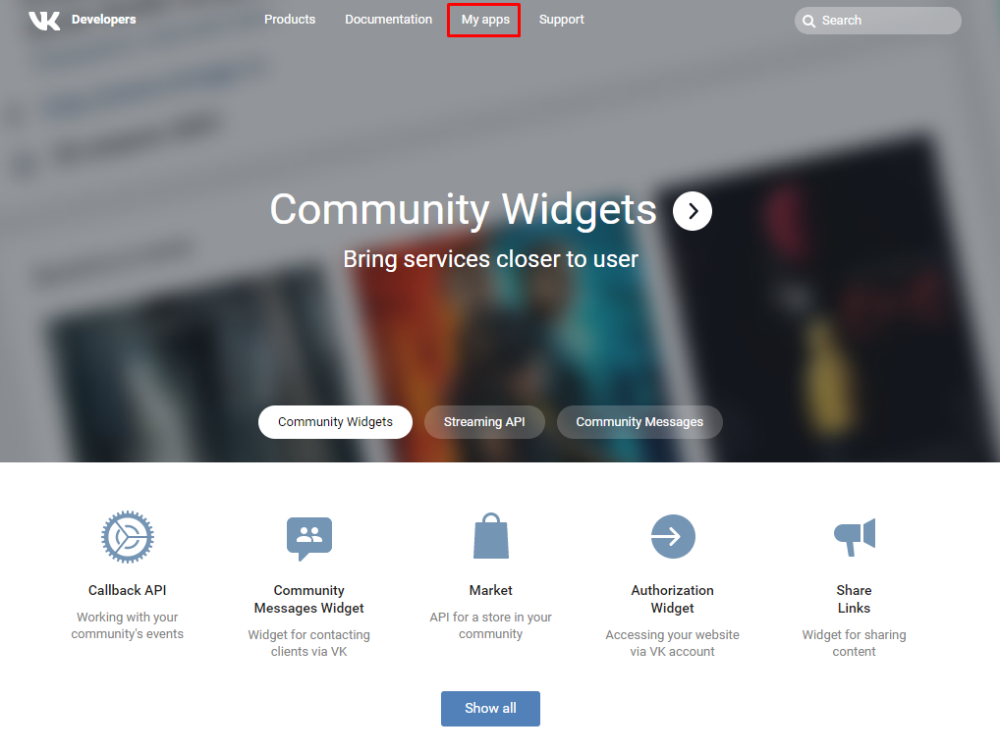

2. Log in.

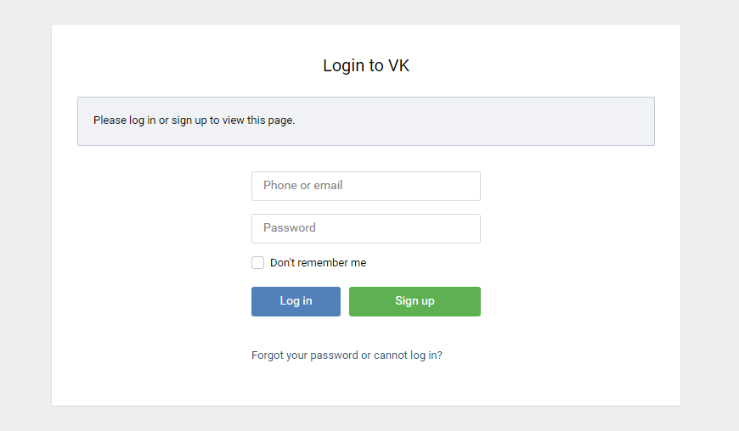

3. Click the “Create application” button.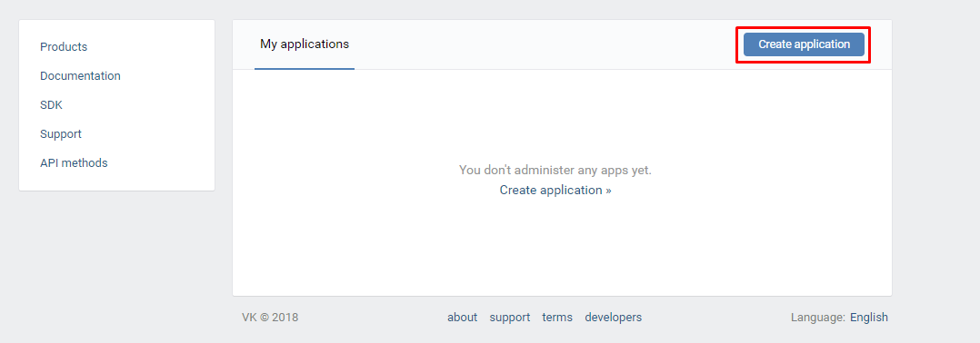

4. Choose the Website platform, fill in all the required fields and click the “Connect Site” button.

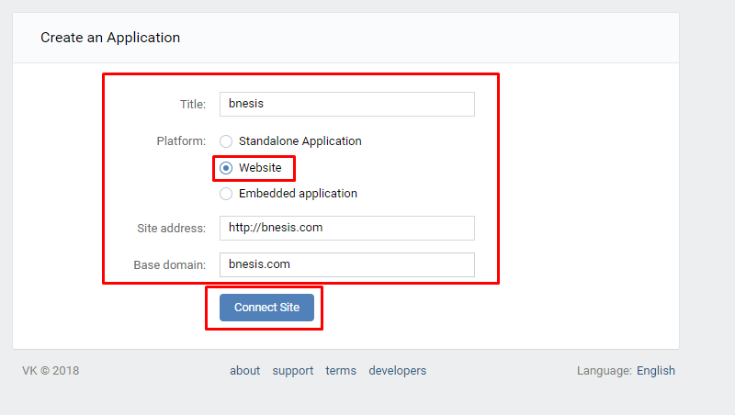

5. In the application settings you need to fill out authorized redirect URL.

Now you can get the required for bNesis “Application ID” and “Secure key”.

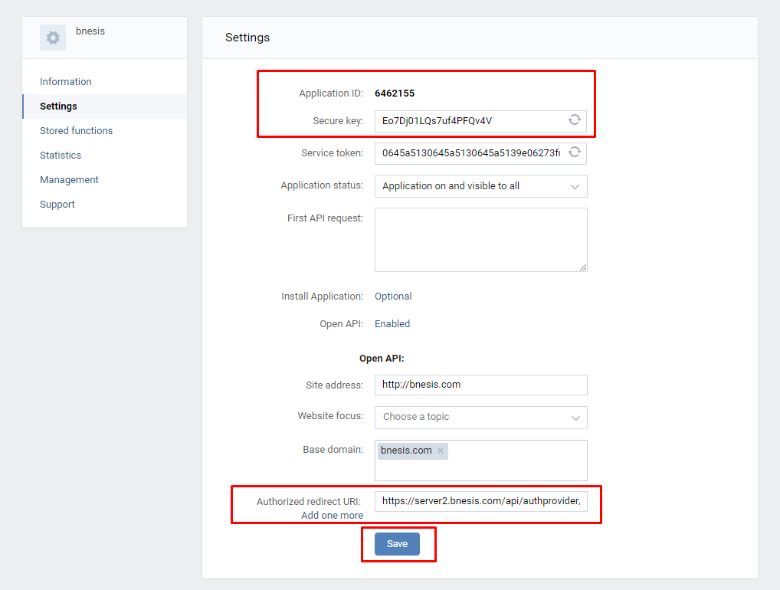

Tried 26 april 2018 by Vladimir Kovalevich.